Date: 05/09/2026
Aim of the Experiment:
Interfacing of LEDs with Arduino Uno.
Objective:
- To familiarize with Arduino UNO Microcontroller: The Brain of an Embedded System.
- To build our first external circuit and control it from the Arduino
- To create a two-LED circuit that blinks alternatively.
- Create an Arduino Sketch to light up three LEDs in sequence for one second.
- Adaptation of a simple 4-bit LED binary counter.

Components/Equipment Required:

Sl No. | Name of the Component/Equipment | Specification | Quantity
1 | Arduino UNO R3 | 16MHz | 1
2 | Arduino UNO cable | USB Type A to B | 1
3 | Resistors (carbon type) | ¼ watt (330Ω) | 4
4 | LED | Red, Blue, Green, White | As per the requirement
5 | Breadboard | 840 Tie points | 1
6 | Jumper Wire | ----------------------- | As per the requirement

Objective 1

Circuit Diagram(TinkerCAD):
Code/Program:
Observation :

Objective 2

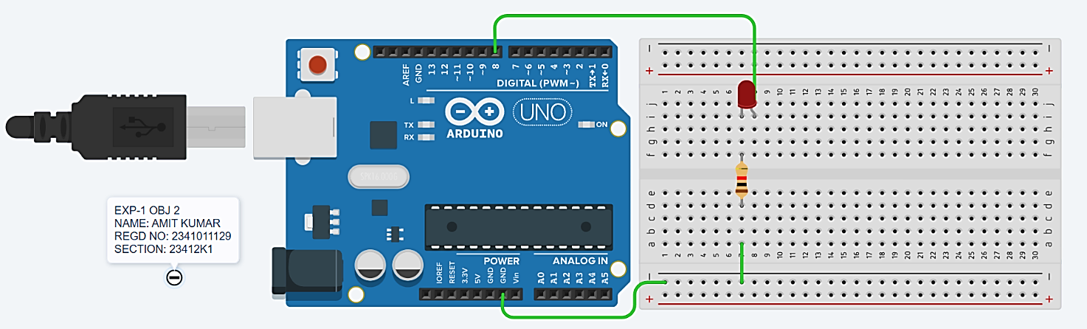
Circuit/Schematic Diagram:
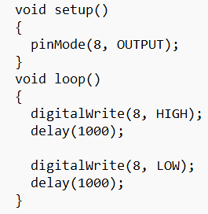
Code:

Observation: The Arduino UNO commands the LED (connected to Digital Pin 8 via a resistor) to continuously blink on and off alternatively with the delay of 1 sec.

Objective 3

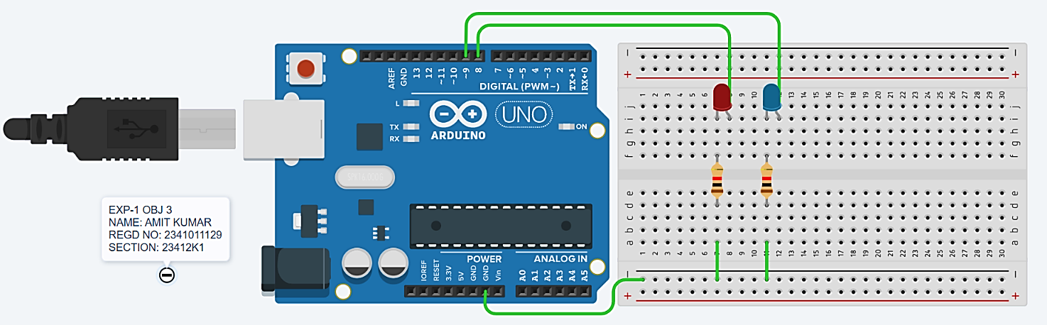
Circuit/Schematic Diagram:

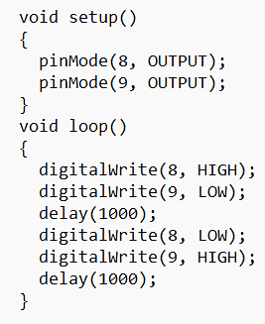
Code:

Observation: The Arduino UNO commands the two LEDs (connected to Digital Pins 8 and 9 via resistors) to continuously blink on and off alternatively with the delay of 1 sec.

Objective 4

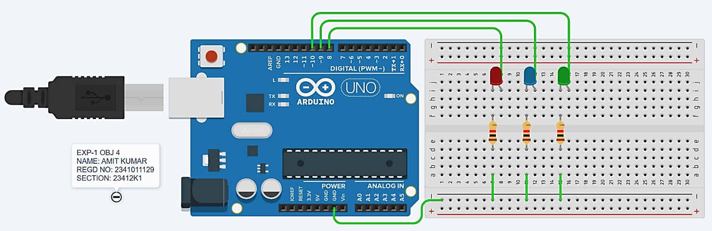
Circuit/Schematic Diagram:

Code:
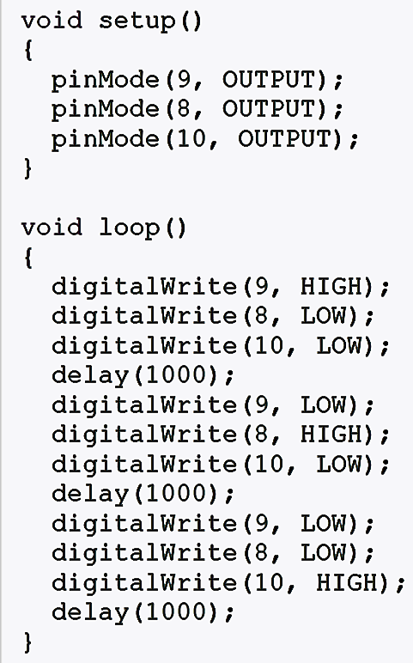
Observation: The Arduino UNO commands the three LEDs (connected to Digital Pins 8, 9, and 10 via resistors) to continuously blink on and off sequentially with a delay of 1 sec.

Objective 5

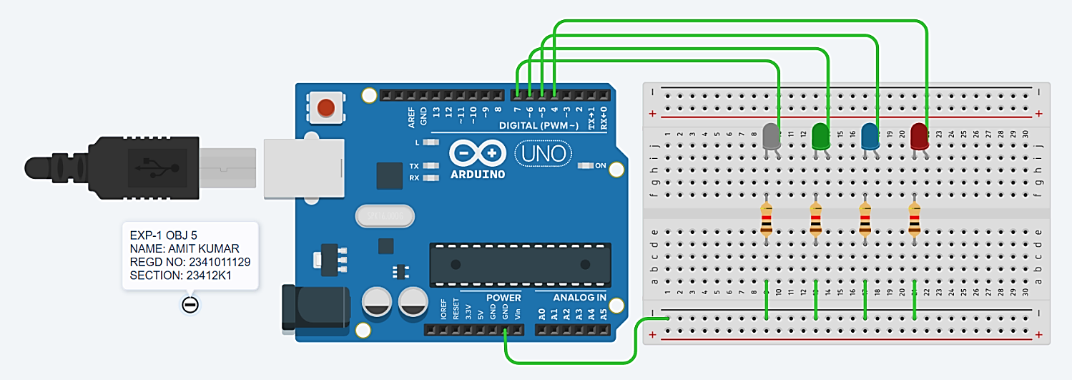
Circuit/Schematic Diagram:

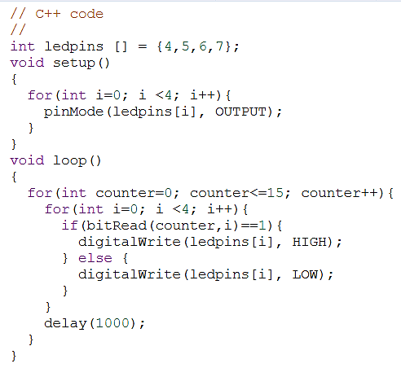
Code:

Observation: The Arduino UNO commands the four LEDs (connected to Digital Pins 4, 5, 6, and 7 via resistors) to act as a 4-bit binary counter, sequentially turning on and off to display the binary equivalents of the numbers 0 through 15 with a delay of 1 second between each count.

Post Experiment Questionnaire:
- List out the different types of Arduino boards available in the market and give one specific application of each board.
Sol^{n}- Arduino UNO : General-purpose prototyping and beginner DIY projects
Arduino Mega 2560 : Complex projects requiring a large number of inputs and outputs
Arduino Nano : Compact, space-constrained, or breadboard-based circuits
Arduino Leonardo : Emulating computer peripherals like custom keyboards or mice
Arduino Due : Projects requiring high-speed processing and complex calculations
Arduino Micro : Small USB-based projects and HID devices

- What are PWM pins in Arduino? How many PWM pins are present in Arduino UNO?
Sol^{n}- PWM (Pulse Width Modulation) pins are digital pins capable of generating pseudo analog output signals by rapidly toggling a digital signal high and low, varying the duty cycle (the percentage of time the signal remains HIGH) to control the average voltage delivered to a load.
The Arduino UNO features 6 PWM pins (specifically digital pins 3, 5, 6, 9, 10, and 11, typically denoted by a tilde ~ on the board).

- Can we give power supply to the Arduino Uno through USB connection and DC power barrel jack simultaneously? Justify your answer.
Sol^{n}- Yes, the Arduino UNO can be connected to both USB and DC power simultaneously. Its power-selection circuitry automatically selects the appropriate power source, so the two sources do not directly conflict.

- Which voltage regulator is present in Arduino module?
Sol^{n}- The Arduino UNO uses a 5V linear voltage regulator (NCP1117) to provide regulated 5V power.

- Explain what is the need for an infinite loop in embedded systems?
Sol^{n}- An infinite loop is required because embedded systems are designed to run continuously and repeatedly monitor inputs, process data, and control outputs.

- How to minimize the number of pins required to connect more number of LEDs.
Sol^{n}- We can use techniques such as multiplexing or shift registers. For example, an 8-bit shift register can control 8 LEDs using only 3 Arduino pins, greatly reducing the number of required I/O pins.

Name of the Student: Amit Kumar
Registration No: 2341011129
Serial No: 22
Branch and Section: CSE - 23412K1

